**Lab Assignment – 8  
Due Date: Oct 17th (Wednesday), 11.59 pm  
Total Points: 100**

**Objectives:**

* Learn to use loops in programming
* Learn to read input from a file

1. Design and implement an application that plays the Hi-Lo guessing game with numbers. The program should pick a random number between 1 and 100 (inclusive), then repeatedly prompt the user to guess the number. On each guess, report to the user that he or she is correct or that the guess is high or low. Continue accepting guesses until the user guesses correctly or chooses to quit.

Use a sentinel value to determine whether the user wants to quit. Count the number of guesses and report that value when the user guesses correctly.  
Hint: You can model your program based on the Calculator.java program (Example 6.3) on page 294 in the textbook. (30 points)

1. Design and implement an application that plays the Rock-Paper-Scissors game against the computer. When played between two people, each person picks one of three options (usually shown by a hand gesture) at the same time, and a winner is determined.

In the game, Rock beats Scissors, Scissors beats Paper, and Paper beats Rock. The program should randomly choose one of the three options (without revealing it), then prompt for the user’s selection. At that point, the program reveals both choices and prints a statement indicating if the user won, the computer won, or if it was a tie. Continue playing until the user chooses to stop, then print the number of user wins, losses, and ties.  
(30 Points)

1. Design and implement a program that reads the grades from the included text file – **Grades.txt** and calculates the following and displays on the terminal window:

* Count of all the students
* Average of all the grades
* Highest grade
* Lowest grade
* Number of students who passed (grade >=60)
* Number of students who got “A” grade ( >= 90)
* Number of students who got “B” grade (>=80 - <90)
* Number of students who received “C” grade (>=70 - <80)
* Number of students who received “D” grade (>= 60 - <70)
* Number of students that received “F” grade (<60)

Please place your Grades.txt file which is included in the downloaded folder in the following location in your NetBeans Project folder as displayed below.

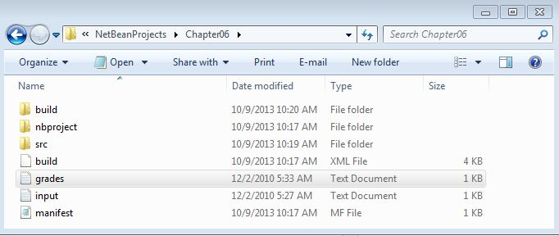

Print this information using appropriate verbiage on the terminal window.

Hint: Refer to the Example 6.2 – Echoing Input from a File (page 292) in your book to find out how to read data from a text file. (40 points)

**Things to Turn in:**

1. In a new Word file and save the file naming convention that we have used for earlier labs. *Use landscape page layout and Courier New font. From here on you will be using landscape page layout for your assignments.*
2. Enter your name at the top of the document.
3. Copy and paste the source code and output window of Program – 1 and include a screen shot of shot of the output window.
4. Copy and paste the source code and output window of Program – 2 and include a screen shot of shot of the output window.
5. Copy and paste the source code and output window of Program – 3 and include a screen shot of shot of the output window.
6. Zip your NetBeans Project folder by going to File 🡪 Zip . Make sure to select a location where you want to save the zipped file and **do not forget to include .zip at the end of the zipped file name.**
7. Submit your word document along with the zipped NetBeans project folder using the ***Lab Assignment – 8 link*** on blackboard by the due date.

***Please note10% of the grade on the assignment is for appropriate comments including the program description at the top. Another 10% will be for style points – following the appropriate naming conventions and proper indentations of the code.***